**Supplementary Materials 3**

Comparison of metabolic fluxes distribution using Escher visualization

**Case 1: Growth maximization vs. TAG overproduction**

Flux distributions for growth maximization and TAG overproduction phenotype were obtained by performing parsimonious flux balance analysis procedure (pFBA) (Lewis et al., 2010) and were visualized in Figure 1 and 2, respectively. In both cases, an uptake rate of 5 mmol glucose.gDW-1.hr-1 was used. On the figures, glucose, triacylglycerol (TAG), and cytoplasmic NADPH (used for fatty acid biosynthesis) were annotated. In TAG production maximization, oxygen uptake and electron transport chain reactions carry smaller amounts of fluxes compared to growth maximization. However, those energy generation fluxes yielding TAG overproduction phenotype were still significant. Oxidative pentose phosphate pathway was determined to be the main source of cytosolic NADPH in both phenotypes. Cytoplasmic malic enzyme was found to be active for TAG overproduction phenotype under pFBA’s flux distribution assumption.

**Case 2: Biomass reaction in carbon vs. nitrogen limitation**

Flux distributions, obtained with using biomass reaction derived for carbon and nitrogen limitation (respectively), were obtained by performing parsimonious flux balance analysis procedure (pFBA) (Lewis et al., 2010) with an uptake rate 5 mmol glucose.gDW-1.hr-1 and growth maximization as objective. In Escher visualization (Figure 3 and 4), we used log2 of the ratio of fluxes using N and C-limited biomass reaction, respectively. For biosynthesis pathways (Figure 3), the flux difference reflects the shift in biomass composition between C and N-limited conditions such as lower carbohydrate (cell wall) and protein biosynthesis and higher lipid biosynthesis fluxes in N-limitation. In central metabolism (Figure 4), due to a higher demand for fatty acid biosynthesis (for lipid) in N-limitation, fluxes through pentose phosphate pathway (PPP) was 1.7-fold higher to overproduce cofactor NADPH. As a result, lower flux values were observed for TCA cycle (i.e., 2.2-fold) because there is carbon lost (i.e., CO2) in oxidative PPP. In this specific case where higher lipid fraction was observed for *R. toruloides* in N-limitation, higher demand in fatty acid synthesis affects the upstream central metabolism due to model’s cofactor balances (i.e., NADPH).

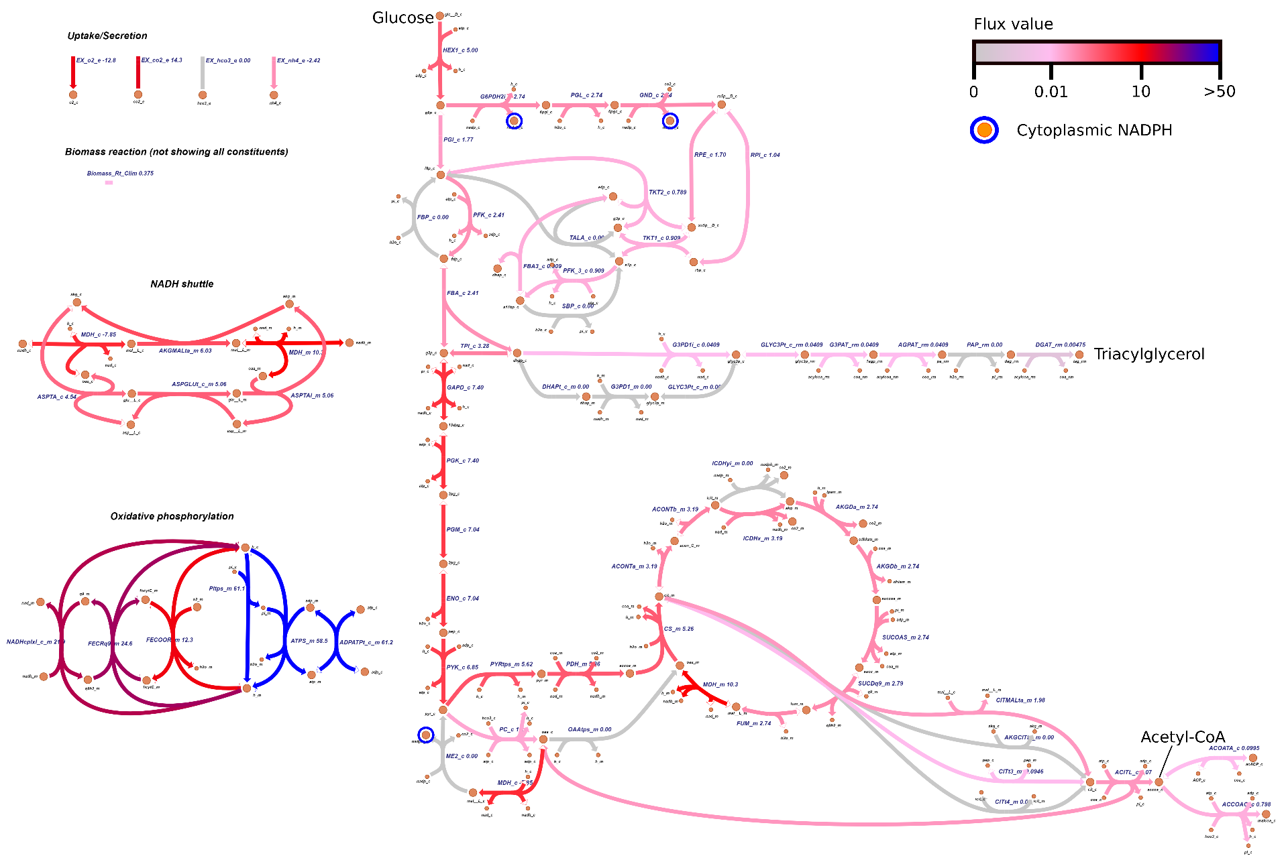

**Figure 1**. Visualization of metabolic fluxes under growth maximization objective.

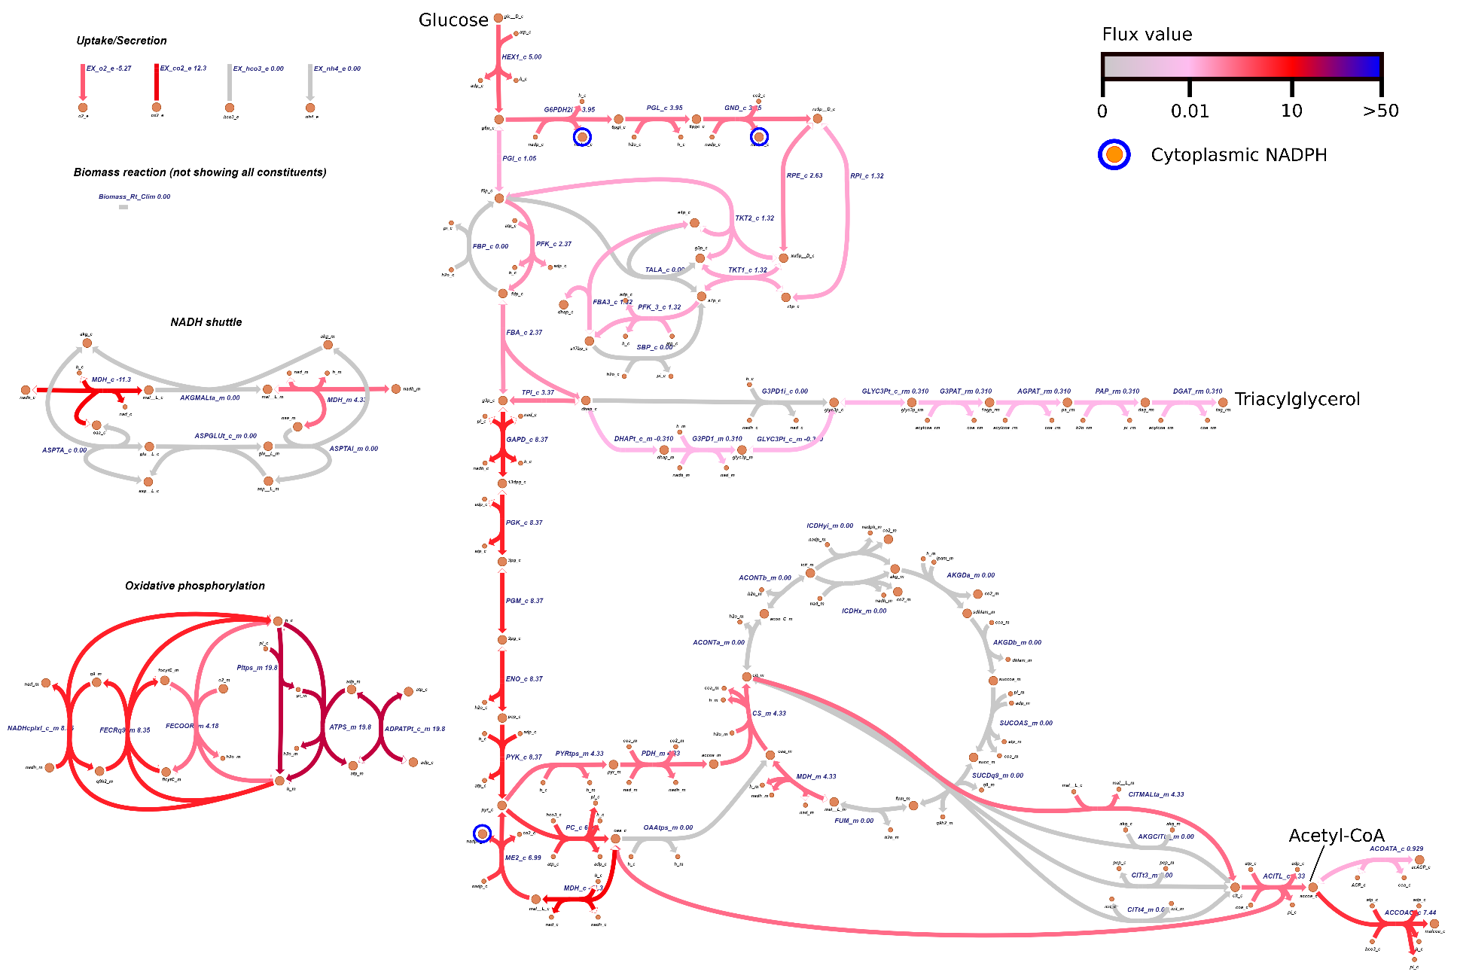

**Figure 2**. Visualization of metabolic fluxes under triacylglycerol production maximization objective.

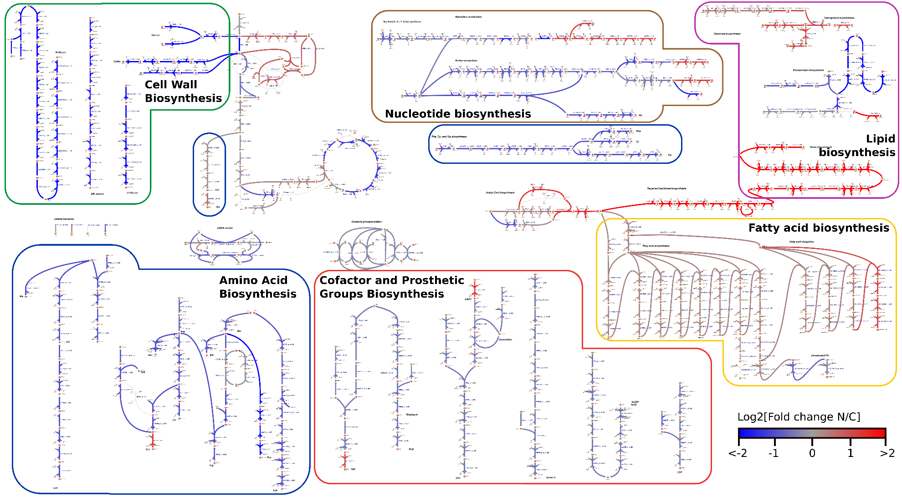

**Figure 3**. Visualization of metabolic fluxes contrast between using carbon vs. nitrogen limitation biomass reaction, for central metabolism and biosynthesis pathways. The values being visualized for each reaction were the log2 of the ratio of fluxes using nitrogen over carbon limitation biomass reaction, respectively.

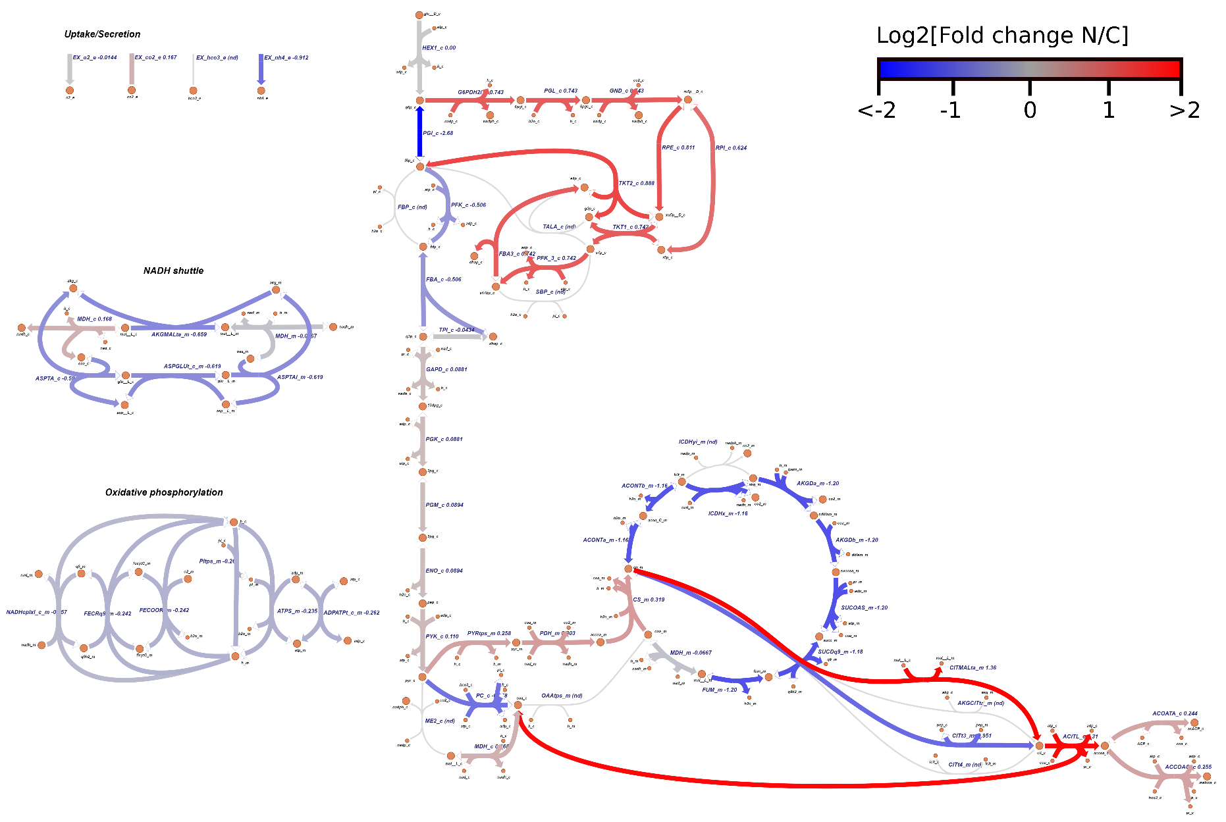

**Figure 4**. Visualization of metabolic fluxes contrast between using carbon vs. nitrogen limitation biomass reaction, for central metabolism. The values being visualized for each reaction were the log2 of the ratio of fluxes using nitrogen over carbon limitation biomass reaction, respectively.

**References**

Lewis, N.E., Hixson, K.K., Conrad, T.M., Lerman, J.A., Charusanti, P., Polpitiya, A.D., Adkins, J.N., Schramm, G., Purvine, S.O., Lopez-Ferrer, D., Weitz, K.K., Eils, R., König, R., Smith, R.D., Palsson, B.Ø., 2010. Omic data from evolved E. coli are consistent with computed optimal growth from genome-scale models. Mol. Syst. Biol. 6, 390. https://doi.org/10.1038/msb.2010.47